**PRACTICAL - 1**

**AIM:**

Evaluation of Database (File System, DBMS, RDBMS, DDBMS).

**File System:­­­­­­­­­­­**

* A File Management system is a DBMS that allows acceSs to single files or tables at a time. In a File System, data is directly stored in set of files. It contains flat files that have no relation to other files (when only one table is stored in single file, then this file is known as flat file).
* It helps you to organizes the data and allows easy retrieval of files when they are required. It mostly consists of different types of files like mp3, mp4, txt, doc, etc. that are grouped into directories.
* A file system enables you to handle the way of reading and writing data to the storage medium. It is directly installed into the computer with the Operating systems such as Windows and

**Features of a File system:**

Here are important elements of the file system:

* It helps you to store data in a group of files.
* Files data are dependent on each other.
* C/C++ and COBOL languages were used to design the files.
* Shared File System Support
* Fast File System Recovery.

**DBMS:**

* A Database Management System (DBMS) is software designed to store, retrieve, define, and manage data in a database.
* DBMS software primarily functions as an interface between the end user and the database, simultaneously managing the data, the database engine, and the database schema in order to facilitate the organization and manipulation of data.

**Features of DBMS:**

* A user-accessible catalog of data
* Transaction support
* Concurrency control with Recovery services
* Authorization services
* The value of data is the same at all places.
* Offers support for data communication
* Independent utility services
* Allows multiple users to share a file at the same time

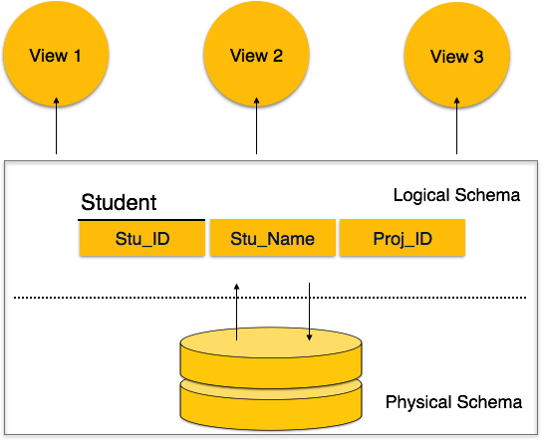

* DBMS software primarily functions as an interface between the end user and the database, simultaneously managing the data, the database engine, and the database schema in order to facilitate the organization and manipulation of data.
* Though functions of DBMS vary greatly, general-purpose DBMS features and capabilities should include: a user accessible catalogue describing metadata, DBMS library management system, data abstraction and independence, data security, logging and auditing of activity, support for concurrency and transactions, support for authorization of access, access support from remote locations, DBMS data recovery support in the event of damage, and enforcement of constraints to ensure the data follows certain rules.

**RDBMS:**

* A relational database management system (RDBMS) refers to a collection of programs and capabilities that is designed to enable the user to create, update, and administer a [relational database](https://www.omnisci.com/technical-glossary/relational-database), which is characterized by its structuring of data into logically independent tables, normally including a Structured Query Language (SQL) application programming interface
* All modern database management systems like SQL, MS SQL Server, IBM DB2, ORACLE, My-SQL and Microsoft Access are based on RDBMS.
* It is a DBMS in which the database is organized and accessed according to the relationships between data items. In a relational database, relationships between data items are expressed by means of tables. Interdependencies among these tables are expressed by data values rather than by pointers. This allows a high degree of data independence.

**DDBMS:**

* A distributed database management system (DDBMS) is a set of multiple, logically interrelated databases distributed over a network. They provide a mechanism that makes the distribution of data transparent to users.
* Databases in the collection are logically interrelated with each other. Often they represent a single logical database.
* Data is physically stored across multiple sites. Data in each site can be managed by a DBMS independent of the other sites.
* The processors in the sites are connected via a network. They do not have any multiprocessor configuration.

**DIFFERENCE**

**1.File System vs DBMS**

|  |  |
| --- | --- |
| **File System** | **DBMS** |
| File system is a software that manages and organizes the files in a storage medium within a computer**.** | DBMS is a software for managing the database. |
| It doesn’t provide backup and recovery of data if it is lost. | It provides backup and recovery of data even if it is lost. |
| Redundant data can be present in a it. | In it there is no redundant data. |
| There is less data consistency in file system | There is more data consistency because of the process of normalization. |
| There is no efficient query processing in file system. | Efficient query processing is there in DBMS. |
| There is no data independence. | In DBMS data independence exists. |
| File systems provide less security in comparison to DBMS. | DBMS has more security mechanisms as compared to file system. |

**2. DBMS VS RDBMS**

|  |  |
| --- | --- |
| **DBMS** | **RDBMS** |
| DBMS stores data as file. | RDBMS stores data in tabular form. |
| Data elements need to access individually. | Multiple data elements can be accessed at the same time. |
| DBMS does not support distributed database. | RDBMS supports distributed database. |
| Normalization is not present. | Normalization is present. |
| It deals with small quantity of data. | It deals with large amount of data. |
| It supports single user. | It supports multiple users. |
| The data in a DBMS is subject to low security levels with regards to data manipulation. | The data in a DBMS is subject to low security levels with regards to data manipulation. |
| Data fetching is slower for the large amount of data. | Data fetching is fast because of relational approach. |
| Examples: XML, Window Registry, etc | Examples: MySQL, PostgreSQL, SQL Server, Oracle, Microsoft Access etc. |

**PRACTICAL - 2**

**AIM:**

Introduction to Oracle (step by step installation, introduction of sql, pl/sql).

1. **Install it by double clicking .exe which you have downloaded**

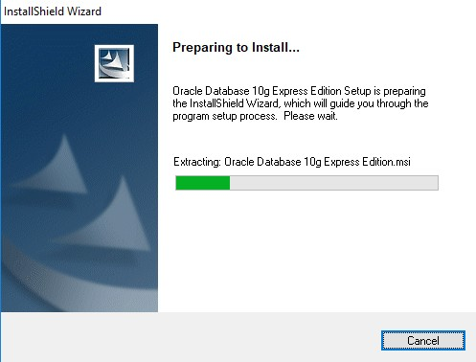

1. **Click on next button**

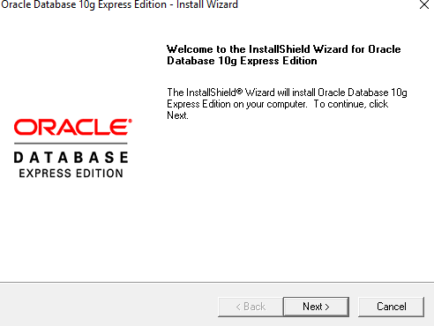

1. **Accept license agreement and click on next button  
     
   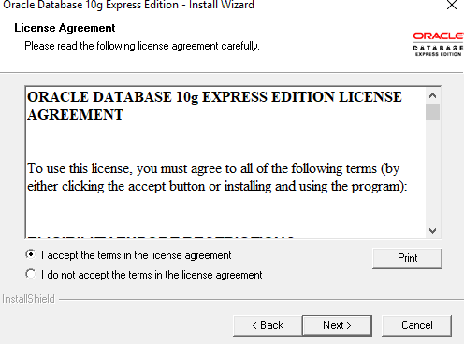**

1. **Click on next button  
     
   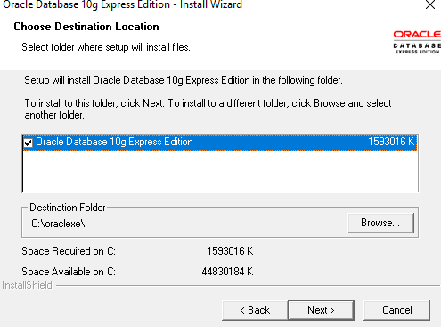**
2. **Enter password and confirm password for SYS and SYSTEM user. Please remember it because once installation will be over you have to enter it. To make it easy to**

**remember give password as : “oracle”  
  
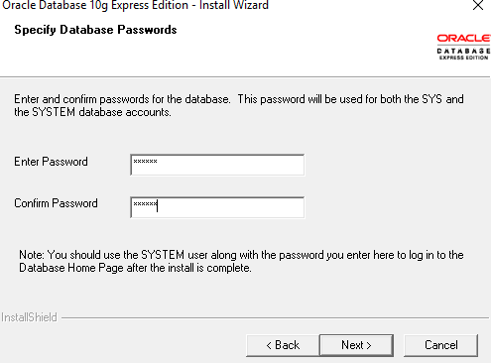**

1. **Click on install button  
     
   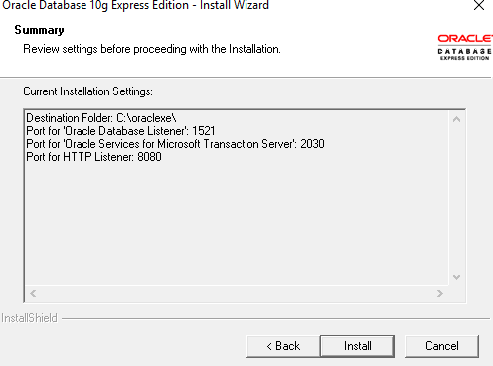**

1. **Click on finish button.  
     
   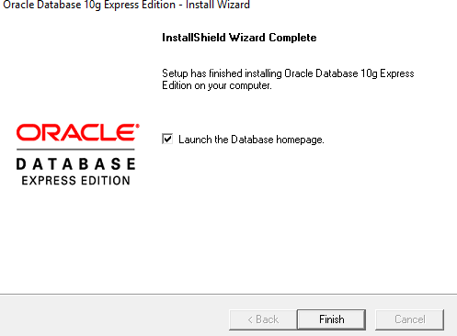**
2. **Enter username as SYS OR SYSTEM and enter your password (Entered in step: 6)  
     
   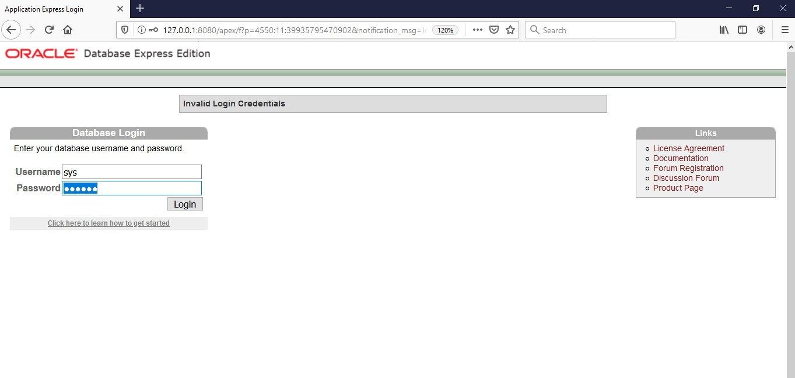**
3. **Click on Administration  
     
   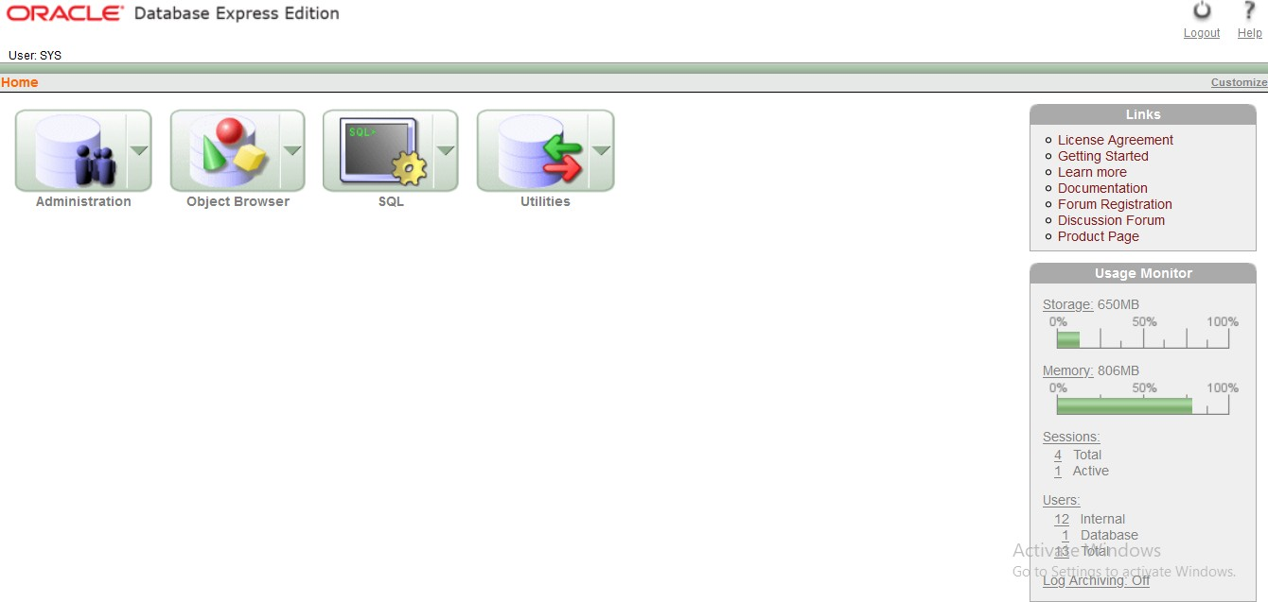**
4. **Now click on “database user drop down button”. From that click on “create user**  
   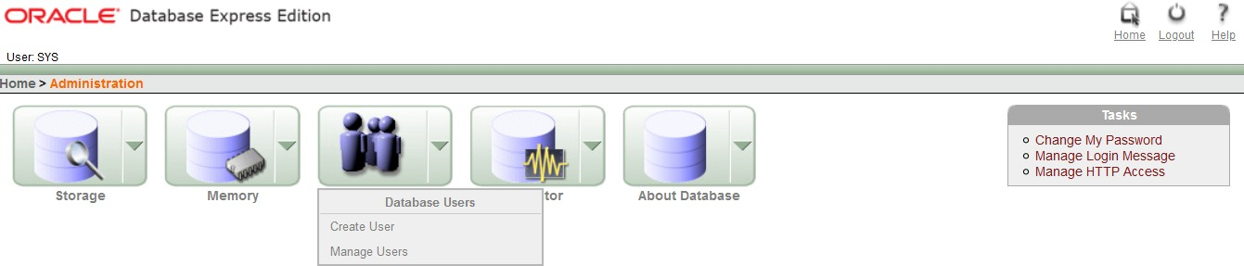
5. **Enter your college roll no in username and give password (NEW) and confirm password. Don’t check expire password, make account status unblocked if it is not. Give all privileges to your user. Finally click on “create” button.**

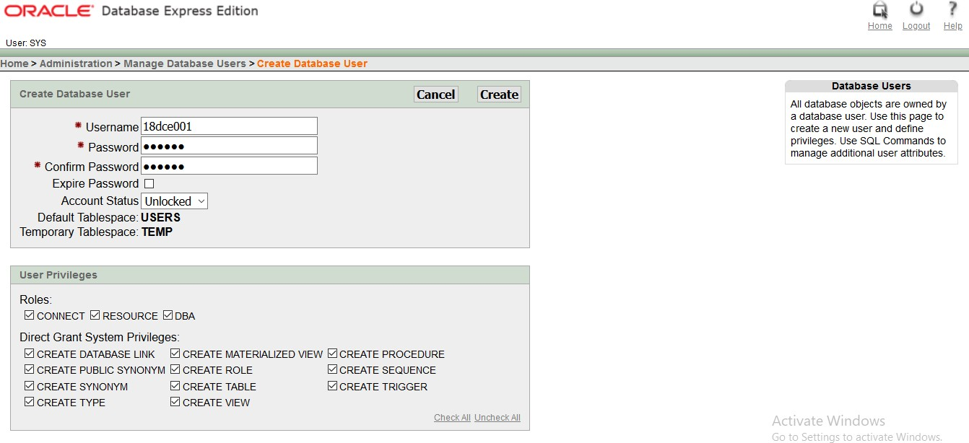

1. **This page will be shown to you. Now click on “logout” button.  
     
   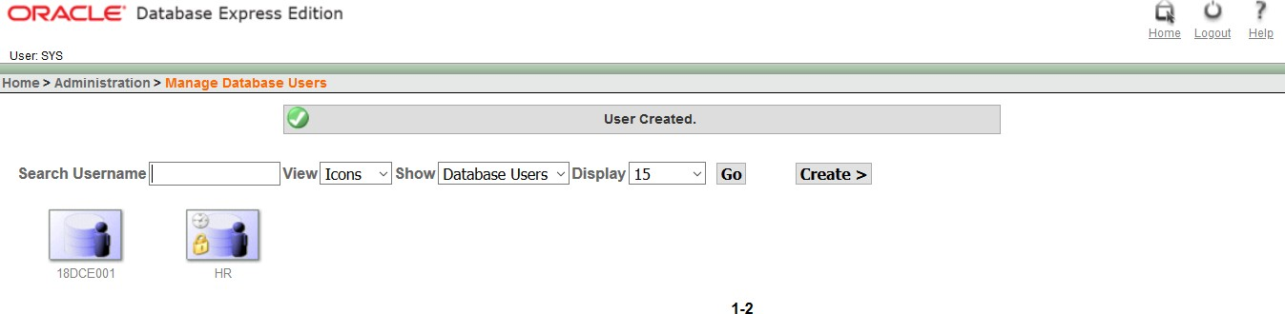**
2. **Click on login  
   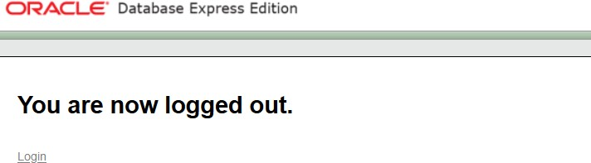**
3. **Enter username and password that you just created and click on “login” button**

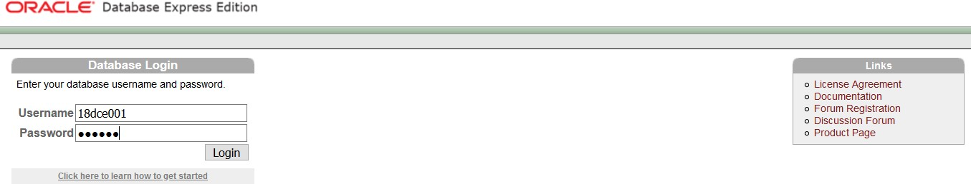

1. **Click on SQL  
     
   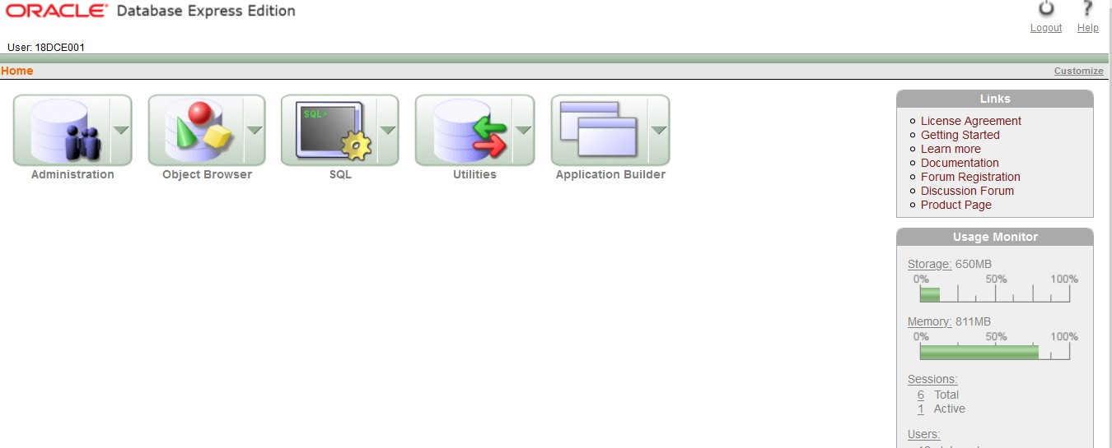**
2. **Home Screen  
     
   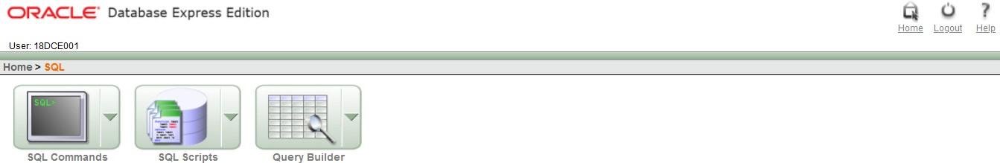**
3. **Congratulation!!! Now you are ready to code SQL and PLSQL.**

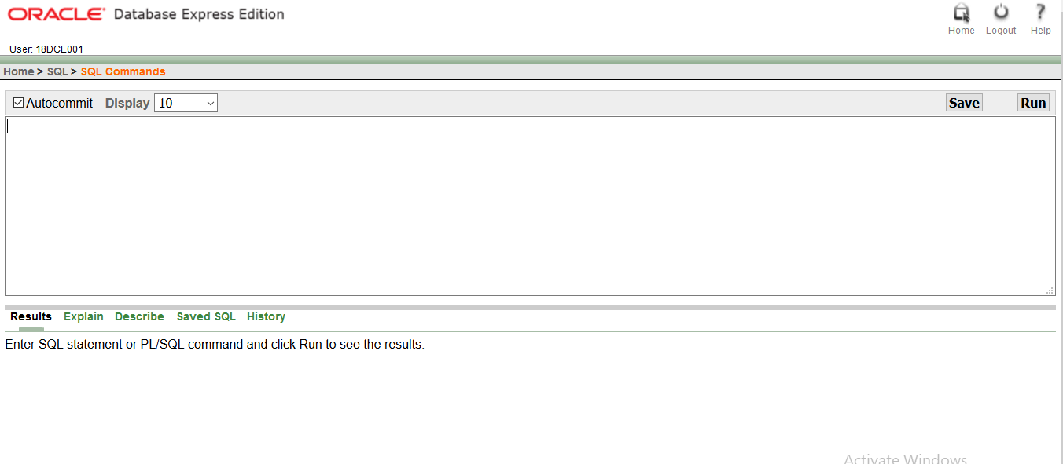

1. **Thank You**

**INTRODUCTION**

**SQL** :

* SQL is Structured Query Language, which is a computer language for storing, manipulating and retrieving data stored in a relational database.
* SQL is the standard language for Relational Database System. All the Relational Database Management Systems (RDMS) like MySQL, MS Access, Oracle, Sybase, Informix, Postgres and SQL Server use SQL as their standard database language.

Also, they are using different dialects, such as −

* MS SQL Server using T-SQL,
* Oracle using PL/SQL,
* MS Access version of SQL is called JET SQL (native format) etc.

**PLSQL :**

* PL/SQL is a block structured language that enables developers to combine the power of SQL with procedural statements. All the statements of a block are passed to oracle engine all at once which increases processing speed and decreases the traffic.

**PRACTICAL – 3**

**AIM:**

|  |
| --- |
| **To study DDL-create and DML-insert commands**.  **(i) Create tables according to the following definition.**   * **CREATE TABLE DEPOSIT (ACTNO VARCHAR2(5), CNAME VARCHAR2(18), BNAME VARCHAR2(18), AMOUNT NUMBER (8,2), ADATE DATE);** * **CREATE TABLE BRANCH (BNAME VARCHAR2(18), CITY VARCHAR2(18));** * **CREATE TABLE CUSTOMERS (CNAME VARCHAR2(19), CITY VARCHAR2(18));** * **CREATE TABLE BORROW (LOANNO VARCHAR2(5), CNAME VARCHAR2(18), BNAME VARCHAR2(18), AMOUNT NUMBER (8,2));**   **From the above given tables perform the following queries**.  **(1) Describe deposit, branch.**  DESC DEPOSIT;  DESC BRANCH;    **(2) Describe borrow, customers.**  DESC BORROW;    DESC CUSTOMERS;    **(3) List all data from table DEPOSIT.**  SELECT * FROM DEPOSIT1;  **(4) List all data from table BORROW.**  SELECT * FROM BORROW;  **(5) List all data from table CUSTOMERS.**  SELECT * FROM CUSTOMERS;  **(6) List all data from table BRANCH.**  SELECT * FROM BRANCH;    **(7) Give account no and amount of depositors.**  SELECT ACTNO, AMOUNT FROM DEPOSIT1;    **(8) Give name of depositors having amount greater than 4000.**  SELECT CNAME FROM DEPOSIT1 WHERE AMOUNT>4000; |

|  |
| --- |
| **(9) Give name of customers who opened account after date '1-12-96'.** SELECT CNAME FROM DEPOSIT1 WHERE ADATE>'01-DEC-96'; |

**(10) Give name of city where branch karolbagh is located.**SELECT CITY FROM BRANCH WHERE BNAME='KAROLBAGH'; 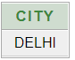

**(11) Give account no and amount of customer having account opened between date 1-12-96 and 1-6- 96.**SELECT ACTNO, AMOUNT FROM DEPOSIT WHERE ADATE BETWEEN '01-DEC-96' AND '01-JUN-96';



**(12) Give names of depositors having account at VRCE.**   
  
SELECT CNAME FROM DEPOSIT1 WHERE BNAME='VRCE'; 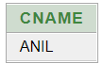

**PRACTICAL - 4**

**AIM:**

**Create the below given table and insert the data accordingly**.

**QUERIES:**

**(1) Retrieve all data from employee, jobs and deposit.**SELECT * FROM EMPLOYEE; 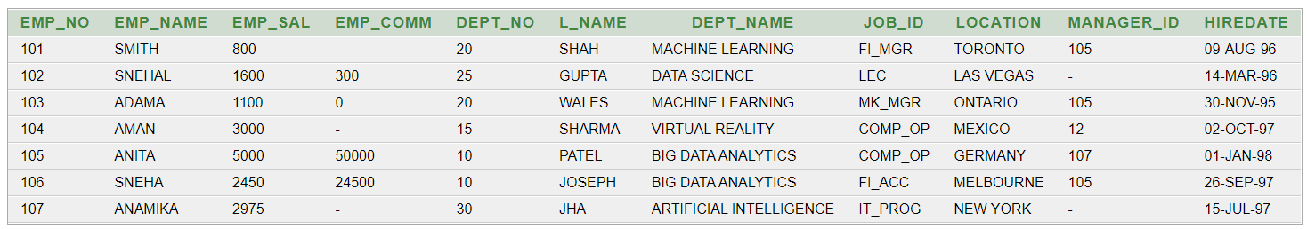

SELECT * FROM JOB;

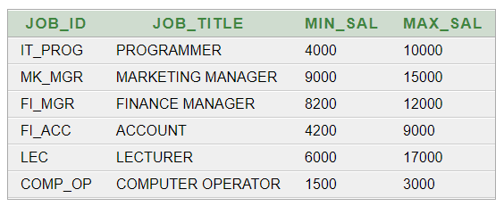

SELECT * FROM DEPOSIT2;  
  
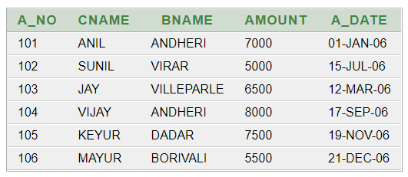

**(2) Give details of account no. and deposited rupees of customers having account opened between dates 01-01-06 and 25-07-06.**   
  
SELECT A_NO, AMOUNT FROM DEPOSIT2 WHERE A_DATE BETWEEN '01-JAN-06' AND '25-JUL-06';  
  
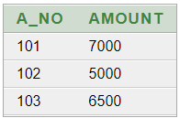

**(3) Display all jobs with minimum salary is greater than 4000.**   
  
SELECT JOB_TITLE FROM JOB WHERE MIN_SAL > 4000;

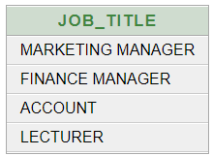

**(4) Display name and salary of employee whose department no is 20. Give alias name to name of employee.**   
  
SELECT EMP_NAME,EMP_SAL FROM EMPLOYEE WHERE DEPT_NO=20;  
  
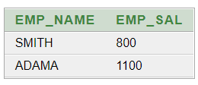

**(5) Display employee no, name and department details of those employee whose department lies in (10,20).**SELECT EMP_NO, EMP_NAME, DEPT_NAME FROM EMPLOYEE WHERE DEPT_NO BETWEEN '10' AND '20';

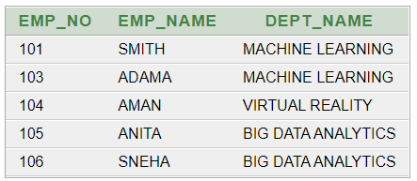

**(6) Display the non-null values of employees.**SELECT * FROM EMPLOYEE WHERE EMP_COMM IS NOT NULL;

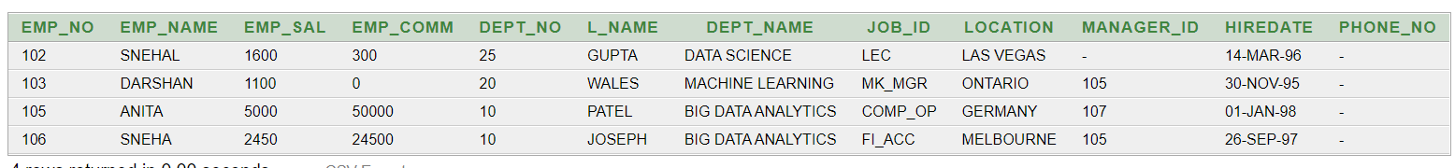

**(7) Display name of customer along with its account no (both column should be displayed as one) whose amount is not equal to 8000 Rs.**SELECT CNAME, A_NO FROM DEPOSIT2 WHERE AMOUNT != '8000';

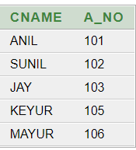

**(8)** **Display the content of job details with minimum salary either 2000 or 4000.**

SELECT * FROM JOB WHERE MIN_SAL=2000 OR MIN_SAL=4000;

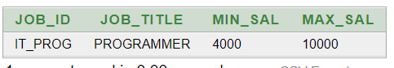

**To study various options of LIKE predicate**

**(1) Display all employee whose name start with ‘A’ and third character is ‘‘a’.**   
  
SELECT * FROM EMPLOYEE WHERE EMP_NAME LIKE 'A_A%';  
  


**(2) Display name, number and salary of those employees whose name is 5 characters long and first three characters are ‘Ani’.**   
  
SELECT EMP_NAME, EMP_NO, EMP_SAL FROM EMPLOYEE WHERE EMP_NAME LIKE 'ANI__';  
  
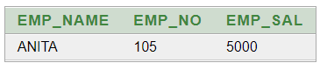

**(3) Display all information of employee whose second character of name is either ‘M’ or ‘N’.**   
  
SELECT * FROM EMPLOYEE WHERE EMP_NAME LIKE '_M%' OR EMP_NAME LIKE '_N%';  
  
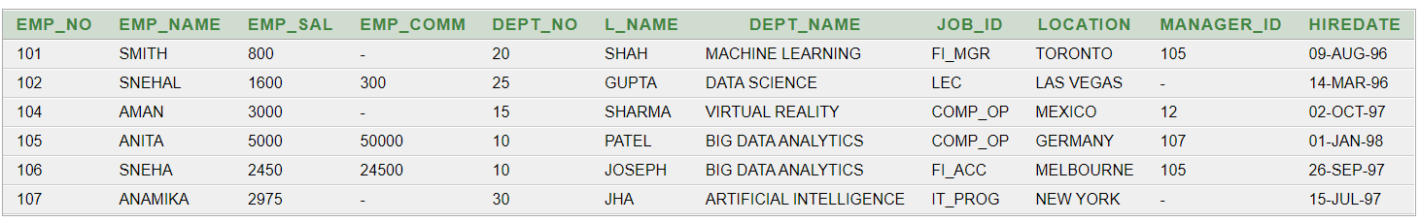

**(4) Find the list of all customer name whose branch is in ‘andheri’ or ‘dadar’ or ‘virar’.**SELECT CNAME FROM DEPOSIT WHERE BNAME IN ('ANDHERI', 'DADAR', 'VIRAR');

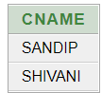

**(5) Display the job name whose first three character in job id field is ‘FI_’.**SELECT JOB_TITLE FROM JOB WHERE JOB_ID LIKE 'FI_%';

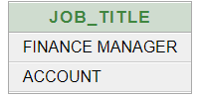

**(6) Display the title/name of job who’s last three character are ‘_MGR’ and their maximum salary is greater than Rs 12000.**SELECT JOB_TITLE FROM JOB WHERE JOB_ID LIKE '%_MGR' AND MAX_SAL>12000;

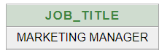

**(7) Display the non-null values of employees and also employee name second character should be ‘n’ and string should be 5-character long.**   
  
SELECT * FROM EMPLOYEE WHERE EMP_COMM IS NOT NULL AND EMP_NAME LIKE '_N___';



**(8) Display the null values of employee and also employee name’s third character should be ‘a’.**SELECT * FROM EMPLOYEE WHERE EMP_COMM IS NULL AND EMP_NAME LIKE '__A%';



**(9) What will be output if you are giving LIKE predicate as ‘%\_%’ ESCAPE ‘\’**

SELECT * FROM JOB WHERE JOB_ID LIKE '%\_%' ESCAPE '\';

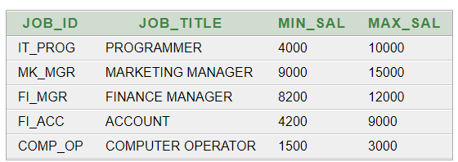

**PRACTICAL - 5**

**AIM: To Perform various data manipulation commands, aggregate functions and sorting concept on all created tables.**

**QUERIES:**

**(1) List total deposit from deposit.**

SELECT SUM(AMOUNT) FROM DEPOSIT2;

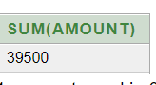

**(2) List total loan from karolbagh branch**   
  
SELECT SUM(AMOUNT) FROM BORROW WHERE BNAME = 'KAROLBAGH';

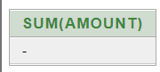

**(3) Give maximum loan from branch vrce.**SELECT MAX(AMOUNT) FROM BORROW WHERE BNAME= 'VRCE';

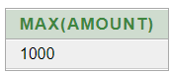

**(4) Count total number of customers**

SELECT COUNT(CNAME) FROM CUSTOMERS;

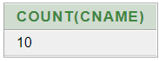

**(5) Count total number of customer’s cities.**SELECT COUNT(CITY) FROM CUSTOMERS;



**(6) Create table supplier from employee with all the columns.**CREATE TABLE SUPPLIER AS SELECT * FROM EMPLOYEE;

SELECT * FROM EMPLOYEE;



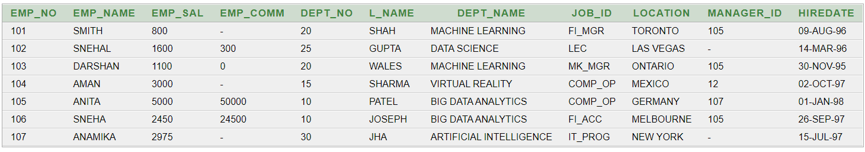

**(7) Create table sup1 from employee with first two columns.**  
CREATE TABLE SUP1 AS SELECT EMP_NO, EMP_NAME FROM EMPLOYEE;



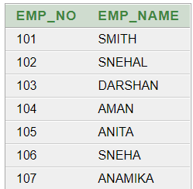

**(8) Create table sup2 from employee with no data**CREATE TABLE SUP2 AS SELECT * FROM EMPLOYEE WHERE EMP_NO = NULL;

SELECT * FROM EMPLOYEE;



**(9) Insert the data into sup2 from employee whose second character should be ‘n’ and string should be 5 characters long in employee name field.**

INSERT INTO SUP2 SELECT * FROM EMPLOYEE WHERE EMP_NAME LIKE '_n___';

SELECT * FROM SUP2;

**(10) Delete all the rows from sup1.**

DELETE SUP1;

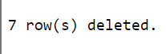

**(11) Delete the detail of supplier whose sup_no is 103.**

DELETE FROM SUPPLIER WHERE EMP_NO=103;

SELECT * FROM SUPPLIER;

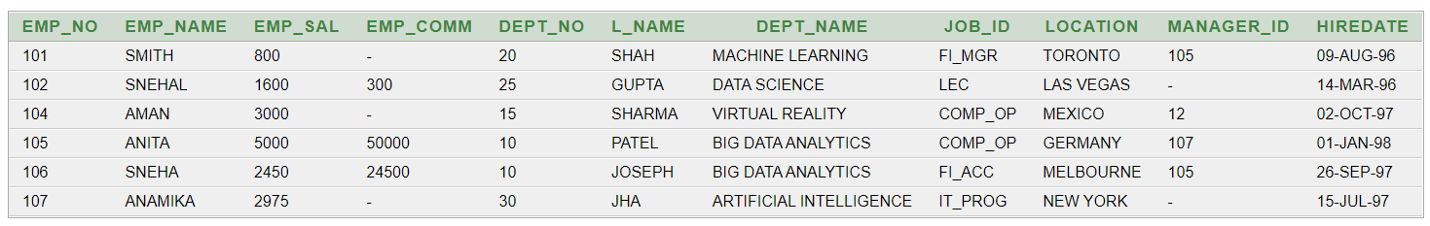

**(12) Rename the table sup2.**

ALTER TABLE SUP2 RENAME TO GLOBAL;

SELECT * FROM GLOBAL;

SELECT * FROM SUP2;

**(13) Destroy table sup1 with all the data.**

DROP TABLE SUP1

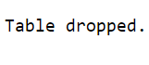

**(14) Update the value dept_no to 10 where second character of emp. name is ‘m’.**

UPDATE EMPLOYEE SET DEPT_NO=10 WHERE EMP_NAME LIKE '_m%';

SELECT * FROM EMPLOYEE;

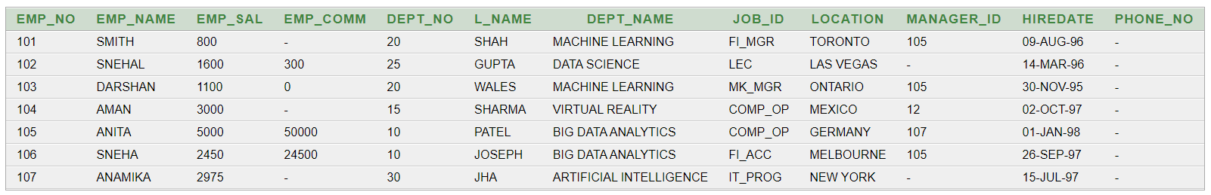

**(15) Update the value of employee name whose employee number is 103.**

UPDATE EMPLOYEE SET EMP_NAME='YATHARTH' WHERE EMP_NO=103;

SELECT * FROM EMPLOYEE;

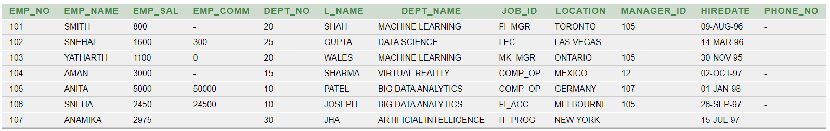

**(16) Add one column phone to employee with size of column is 10.**

ALTER TABLE EMPLOYEE ADD PHONE_NO NUMBER(10,0);

SELECT * FROM EMPLOYEE;

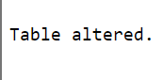

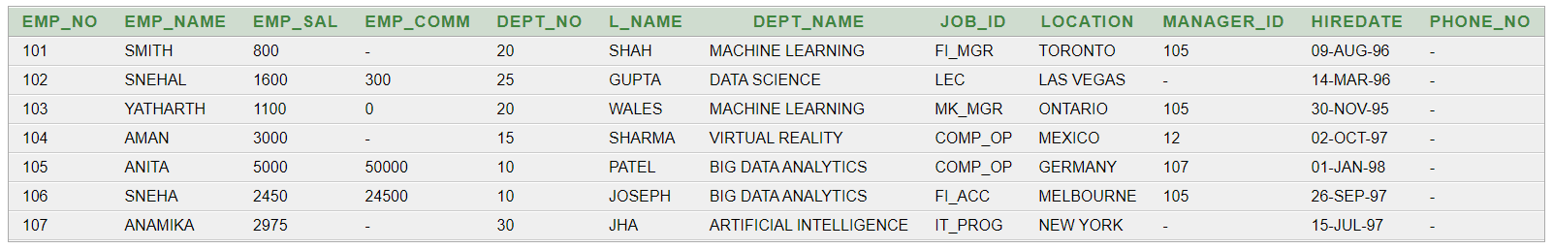

**(17) Modify the column emp_name to hold maximum of 30 characters.**

ALTER TABLE EMPLOYEE MODIFY EMP_NAME varchar(30);

SELECT * FROM EMPLOYEE;



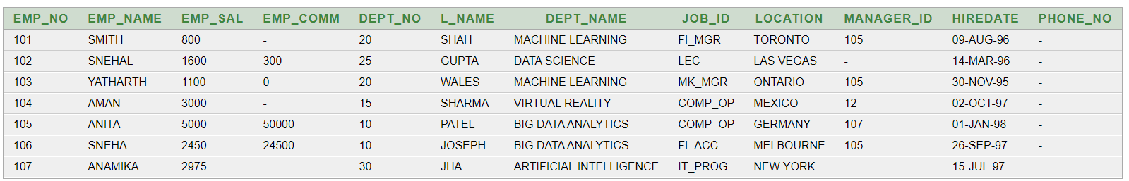

**(18) Count the total no as well as distinct rows in dept_no column with a condition of salary greater than 1000 of employee**

SELECT COUNT(DISTINCT DEPT_NO) FROM EMPLOYEE WHERE EMP_SAL > 1000;

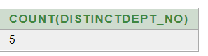

**(19) Display the detail of all employees in ascending order, descending order of their name and no.**

SELECT * FROM EMPLOYEE ORDER BY EMP_NAME ASC , EMP_NO DESC;

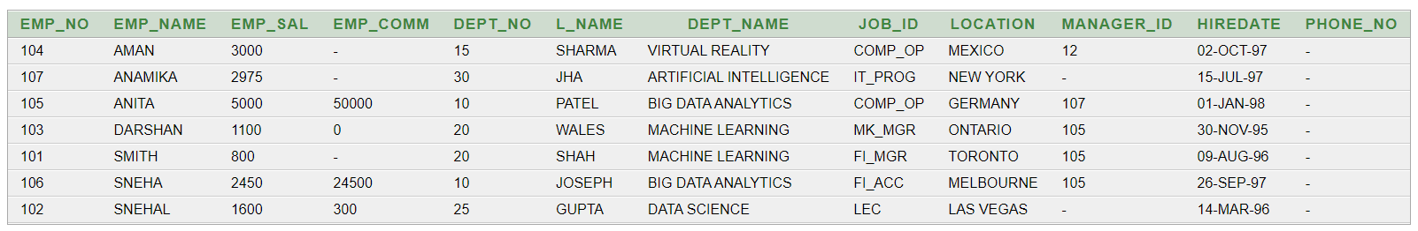

**(20) Display the dept_no in ascending order and accordingly display emp_comm in descending order.**

SELECT * FROM EMPLOYEE ORDER BY DEPT_NO ASC, EMP_COMM DESC;

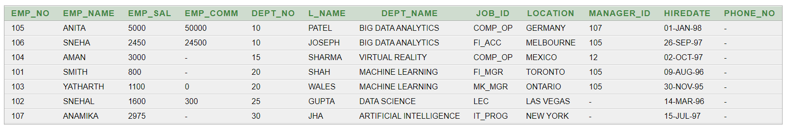

**(21) Update the value of emp_comm to 500 where dept_no is 20.**

UPDATE EMPLOYEE SET EMP_COMM = 500 WHERE DEPT_NO = 20;

SELECT * FROM EMPLOYEE;

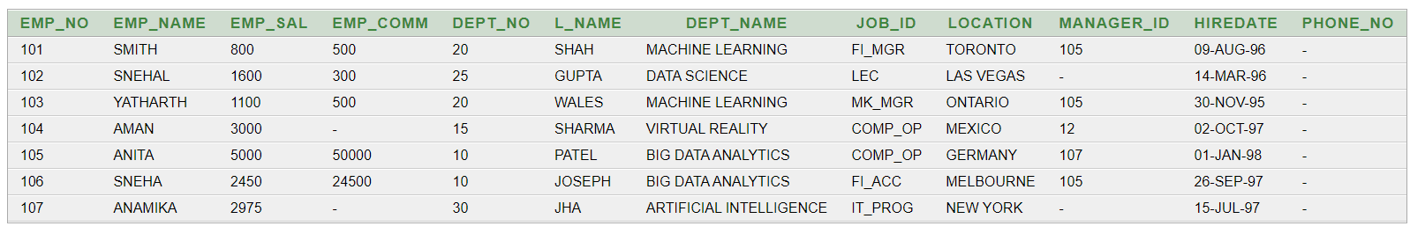

**(22) Display the emp_comm in ascending order with null value first and accordingly sort employee salary in descending order.**

SELECT EMP_COMM, EMP_SAL FROM EMPLOYEE ORDER BY EMP_COMM ASC NULLS FIRST, EMP_SAL DESC;

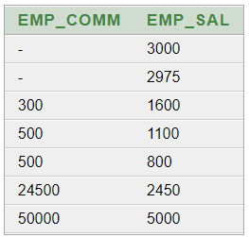

**(23) Display the emp_comm in ascending order with null value last and accordingly sort emp_no in descending order.**

SELECT EMP_COMM, EMP_NO FROM EMPLOYEE ORDER BY EMP_COMM ASC NULLS LAST, EMP_NO DESC;

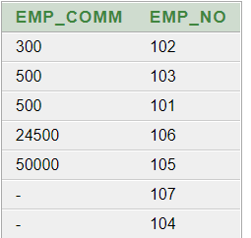

**PRACTICAL - 6**

**AIM: To study Single-row functions.**

**QUERIES:**

**(1) Write a query to display the current date. Label the column Date**

SELECT SYSDATE AS "DATE" FROM DUAL;

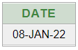

**(2) For each employee, display the employee number, salary, and salary increased by 15% and expressed as a whole number. Label the column New Salary**SELECT EMP_NO, EMP_NAME,EMP_SAL, EMP_SAL+(EMP_SAL*15/100) "NEW SALARY" FROM EMPLOYEE;

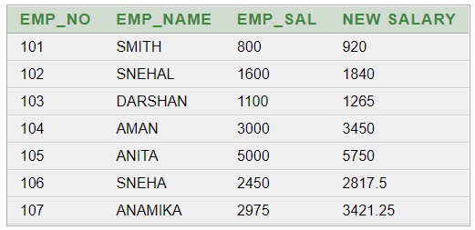

**(3) Modify your query no (2) to add a column that subtracts the old salary from the new salary. Label the column Increase**

SELECT EMP_NO,EMP_NAME,EMP_SAL,EMP_SAL+(EMP_SAL*15/100) "NEW SALARY",(EMP_SAL+(EMP_SAL*15/100))- EMP_SAL "INCREASE" FROM EMPLOYEE;  
  
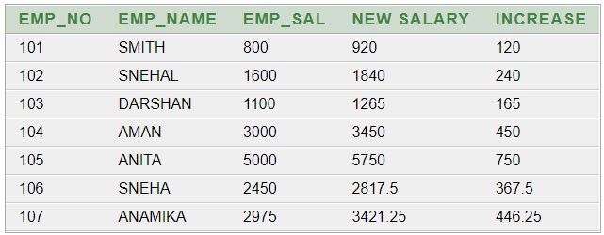

**(4) Write a query that displays the employee’s names with the first letter capitalized and all other letters lowercase, and the length of the names, for all employees whose name starts with J, A, or M. Give each column an appropriate label. Sort the results by the employees’ last names.**SELECT INITCAP(EMP_NAME) "NAME", LENGTH(EMP_NAME) "LENGTH OF NAME" FROM EMPLOYEE WHERE EMP_NAME LIKE 'J%' OR EMP_NAME LIKE 'A%' OR EMP_NAME LIKE 'M%' ORDER BY EMP_NAME; 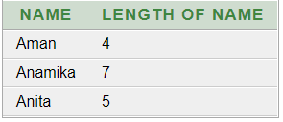

**(5) Write a query that produces the following for each employee:**

**<employee last name> earns <salary> monthly**SELECT EMP_NAME || ' EARNS ' || EMP_SAL || ' MONTHLY' FROM EMPLOYEE;  
 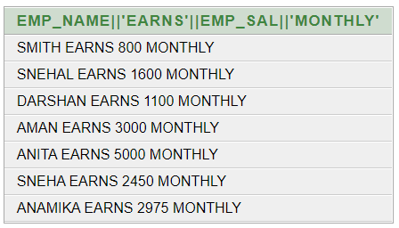

**(6) Display the name, date, number of months employed and day of the week on which the employee has started. Order the results by the day of the week starting with Monday.**

SELECT EMP_NAME, HIREDATE, ROUND (MONTHS_BETWEEN (SYSDATE, HIREDATE)) AS MONTHS, TO_CHAR(HIREDATE, 'DAY') AS "DAY" FROM EMPLOYEE ORDER BY TO_CHAR(HIREDATE, 'DAY') DESC;

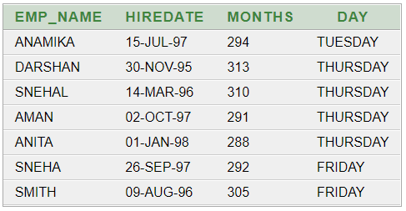

**(7) Display the date of emp in a format that appears as Seventh of June 1994 12:00:00 AM.**

SELECT L_NAME, HIREDATE, TO_CHAR(HIREDATE, 'DDSPTH "OF" MONTH YYYY HH:MM:SS AM') "DATE OF EMP" FROM EMPLOYEE;  
  
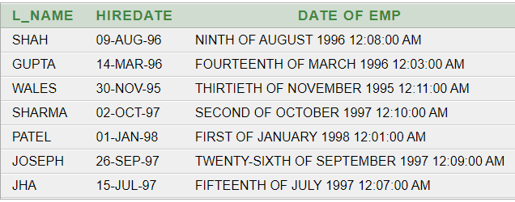

**(8) Write a query to calculate the annual compensation of all employees (sal +comm.).**SELECT EMP_NAME, EMP_SAL, EMP_COMM, (EMP_SAL+ ((EMP_SAL * EMP_COMM) / 100)) AS "TOTAL_SALARY" FROM EMPLOYEE;  
  
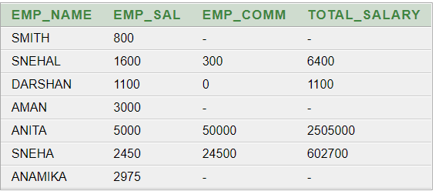

**PRACTICAL - 7**

**AIM: Displaying data from Multiple Tables (join)**

**QUERIES:**

**(1) Give details of customers ANIL.**

SELECT CUSTOMERS.CNAME, CUSTOMERS.CITY, BORROW.LOANNO, BORROW.BNAME, BORROW.AMOUNT FROM CUSTOMERS INNER JOIN BORROW ON CUSTOMERS.CNAME=BORROW.CNAME WHERE CUSTOMERS.CNAME='ANIL';



**(2) Give name of customer who are borrowers and depositors and having living city nagpur**

SELECT DEPOSIT1.CNAME FROM DEPOSIT1, BORROW WHERE DEPOSIT1.CNAME=BORROW.CNAME AND DEPOSIT1.BNAME IN('VRCE','AJNI','DHARMPETH');

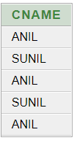

**(3) Give city as their city name of customers having same living branch.**

SELECT CNAME, CUSTOMERS.CITY FROM CUSTOMERS, BRANCH WHERE CUSTOMERS.CITY=BRANCH.CITY;



**(4) Write a query to display the last name, department number, and department name for all employees.**

SELECT EMP_NAME, DEPT_NO,DEPT_NAME FROM EMPLOYEE;

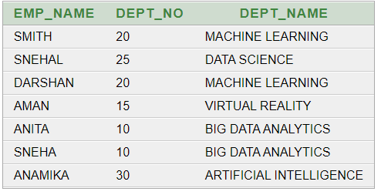

**(5) Create a unique listing of all jobs that are in department 30. Include the location of the department in the output**

SELECT DISTINCT(DEPT_NAME), JOB_ID,LOCATION FROM EMPLOYEE WHERE DEPT_NO='30';

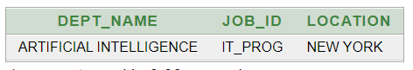

**(6) Write a query to display the employee name, department number, and department name for all employees who work in NEW YORK.**

SELECT EMP_NAME,DEPT_NO, DEPT_NAME FROM EMPLOYEE WHERE LOCATION='NEW YORK';

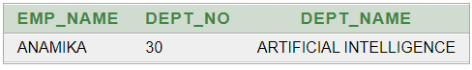

**(7) Display the employee last name and employee number along with their manager’s last name and manager number. Label the columns Employee, Emp#, Manager, and Mgr#, respectively.**

SELECT A.EMP_NAME AS "EMPLOYEE", A.EMP_NO AS "EMP#", B.EMP_NAME AS "MANAGER", B.EMP_NO AS "MGR#" FROM EMPLOYEE A, EMPLOYEE B WHERE B.EMP_NO=A.MANAGER_ID;

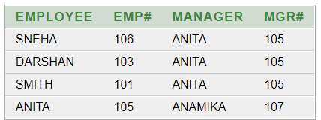

**(8) Create a query to display the name and hire date of any employee hired after employee “smith”.**

SELECT EMP_NAME, HIREDATE FROM EMPLOYEE WHERE HIREDATE>(SELECT HIREDATE FROM EMPLOYEE WHERE EMP_NAME='SMITH');

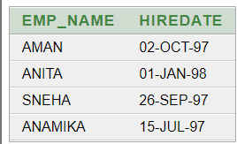

**PRACTICAL - 8**

**AIM: To apply the concept of Aggregating Data using Group functions.**

**QUERIES:**

**(1) List total deposit of customer having account date after 1-jan-96.**

SELECT SUM(AMOUNT) FROM DEPOSIT1 WHERE ADATE > '1-JAN-96'

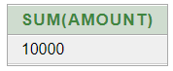

**(2) List total deposit of customers living in city Nagpur.**SELECT SUM(AMOUNT) FROM DEPOSIT1 NATURAL JOIN BRANCH WHERE CITY='NAGPUR';

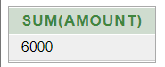

**(3) List maximum deposit of customers living in bombay.**SELECT SUM(AMOUNT) FROM DEPOSIT1 NATURAL JOIN BRANCH WHERE CITY='BOMBAY';

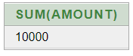

**(4) Display the highest, lowest, sum, and average salary of all employees. Label the columns Maximum, Minimum, Sum, and Average, respectively. Round your results to the nearest whole number.**SELECT MAX (EMP_SAL) "MAXIMUM" ,MIN(EMP_SAL) "MINIMUM",SUM(EMP_SAL) "SUM", AVG (EMP_SAL) "AVERAGE" FROM EMPLOYEE;

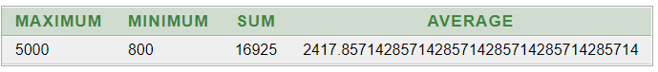

**(5) Write a query that displays the difference between the highest and lowest salaries. Label the column DIFFERENCE.**SELECT MAX(EMP_SAL)-MIN(EMP_SAL) "DIFFERENCE" FROM EMPLOYEE; 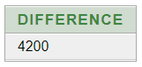

**(6) Create a query that will display the total number of employees and, of that total, the number of employees hired in 1995, 1996, 1997, and 1998**SELECT COUNT (EMP_NO) FROM EMPLOYEE;

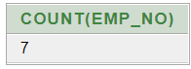

**(7) Find the average salaries for each department without displaying the respective department numbers.**SELECT AVG(EMP_SAL) FROM EMPLOYEE GROUP BY DEPT_NO;

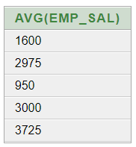

**(8) Write a query to display the total salary being paid to each job title, within each department.**SELECT DEPT_NO,SUM(EMP_SAL) FROM EMPLOYEE GROUP BY DEPT_NO;

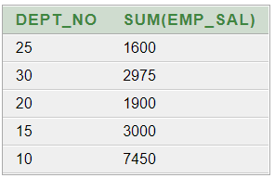

**(9) Find the average salaries > 2000 for each department without displaying the respective department numbers.**

SELECT AVG(EMP_SAL) FROM EMPLOYEE GROUP BY DEPT_NO HAVING AVG(EMP_SAL)> 2000; 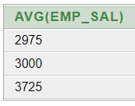

**(10) Display the job and total salary for each job with a total salary amount exceeding 3000 and sorts the list by the total salary.**SELECT DEPT_NO,SUM(EMP_SAL) FROM EMPLOYEE GROUP BY DEPT_NO HAVING SUM(EMP_SAL) > 3000 ORDER BY SUM(EMP_SAL);

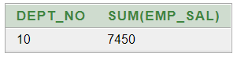

**(11) List the branches having sum of deposit more than 5000 and located in city bombay.**

SELECT BNAME FROM DEPOSIT1 NATURAL JOIN BRANCH GROUP BY BNAME HAVING SUM(AMOUNT)>5000;

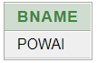

**PRACTICAL - 9**

**AIM: Displaying data from Multiple Tables (join)**

**QUERIES:**